**Predicting Short Term Trucking Rates with Random Forests**

1. **Introduction**
2. **Modes of Transportation**
3. **Factors Affecting Truckload Transportation Rates**
4. **Problem and Data**
5. **Model Development**
   1. **Data cleaning – outliers**
   2. **Feature engineering**
   3. **Train/test data split**
   4. **Baseline model**
   5. **Random forest model**
   6. **Analysis of results**
6. **Move model to production**
7. **Future work**
8. **Introduction**

In this post, we present a random forest model to predict short term trucking rates.

Transportation rates are driven by different modes of transportation (air, road, rail, and ocean). In this work, we focus on trucking related transportation modes, Full Truckload (FTL) and Less than Truckload (LTL).

Full Truckload (FTL): An entire truck is used for transportation. In the FTL market, truck delivers to destination directly from shipper’s location using a dedicated truck. The rate is the same for the use of the full truck whether the truck is 100% full or 25% full and may be different depending on where the shipment starts and ends. Capacity of a truck can be measured in total weight, total cube, or total number of pallets. Various truck types are used such as regular dry van, refrigerated, flatbed, tanker, and 48- and 53-foot trailers. An FTL carrier may hold 45,000 pounds of product.

Less than Truckload (LTL): Companies use LTL when they have a small load to ship to a destination. In this case, hiring an entire truck to make the delivery is not economical. Trucking company picks up the load, combines it with other companies’ pickup or deliveries, and makes the trip to complete a route of deliveries to customer locations. An LTL carrier may hold up to 15,000 pounds of product.

Different trailer types carry different products. The main types include dry van, flatbed, refrigerated/temperature-controlled trailer and tank. Dry van is the most popular one. The flatbed trailer does not have a side wall or ceiling and used to carry construction materials or large machinery. Food and medicines are normally hauled by temperature-controlled. Tanks, which are used to haul refined oil products or chemicals in the liquid form.

Two types of services exists to cover freight transportation requirements, through long-term contracts or on the spot market. Contract carriers is used most frequently. The contract is typically a one-year commitment, which consists of origin/destination, service requirement, volume and any other factors that affect the price.

Spot market is used to obtain a rate when there is no availability in the contract market (lane does not exists or rate is not accepted).

1. **Factors Affecting Truckload Transportation Rates**

**LTL,**

**From, to, distance, mode, trailer type, volume**

**Calculate base rate**

trans_matrix['TOTAL_RATE'] = trans_matrix['RATE'] + (trans_matrix['DISTANCE'] * trans_matrix['FUEL_SURCHARGE'])

In the U.S. and Canada, these rates are usually based on the source, destination, weight of the shipment, and shipment class (a measure to define the density of the product, whether it is hazardous, and other measures that impact the cost for the carrier to move the item)

the more product shipped, the lower the cost per unit to deliver it

minimums and fuel surcharges are often assessed (TL and LTL)

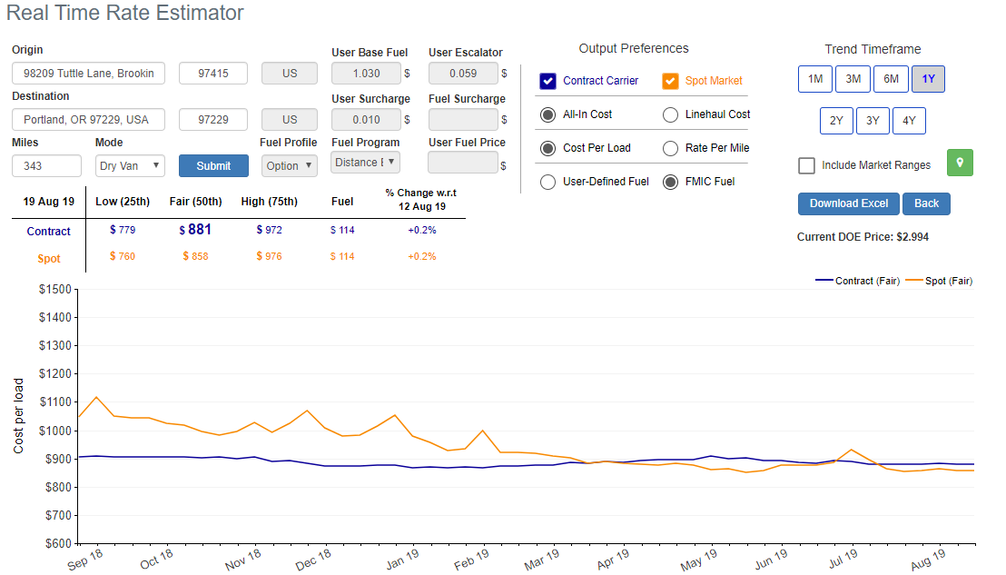

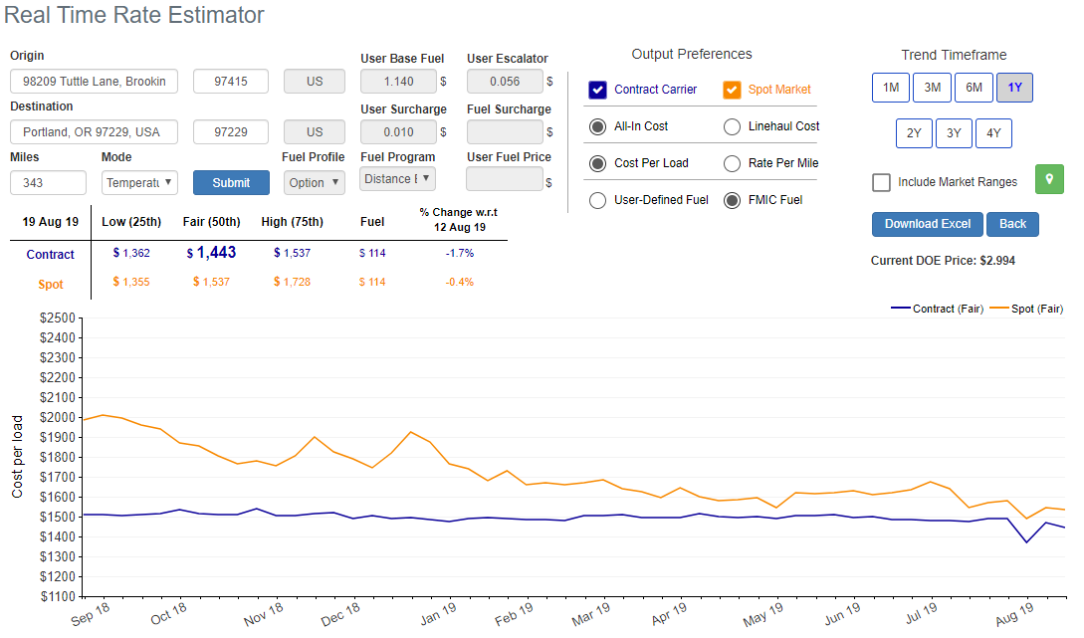

1. **Problem and Data**

Consider a network of customers and distribution centers (Fig1). Products are delivered to each customer from distribution centers using trucks. Our objective is to allocate customers to distribution centers by minimizing the total transportation cost. Since transportation cost increases as distance between distribution center and customer decreases, we tend to allocate each customer to the closest distribution center.

Transportation cost is one of the major factors affect allocation of distribution centers to customers.

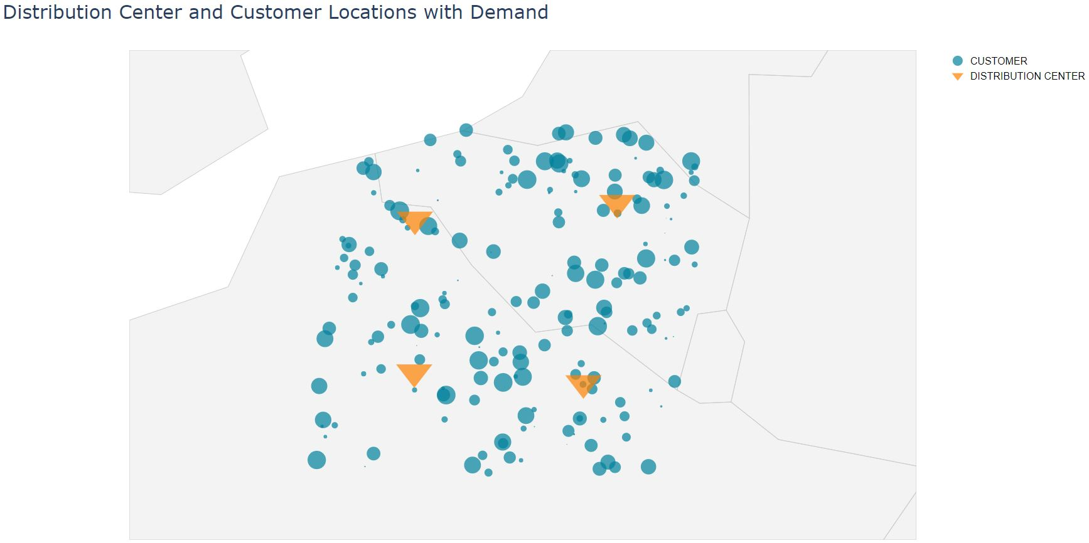

Figure 1: Customer and distribution center network